Lab 10-1 Using Dynamic Repository Variable
Goals | To create and use a dynamic repository variable.
Scenario | ABC has implemented separate partitions for customer data. However, when the partitions get reloaded, 50% of the data will be loaded into the first partition and 50% of the data will be loaded into the second partition. The variable will determine how the data is split between the partitions.
Outcome | New initialization block CustomerDataSplit with EndPartOne variable.  In the Business layer, modified Customers sources.
Time | 10 – 15 minutes
Environment | 
Instructions:
- Open the repository file.
  - Shut down the Siebel Analytics Server service.
  - Double-click C:\SiebelAnalytics\Repository\abc.rpd to open the repository. Log in as Administrator with no password.
- Create the initialization block.
  - Select Manage > Variables.
  - Select Action > New > Initialization Block.
  - In Name, type CustomerDataSplit to name the block.
  - Click the Browse button.
  - Select the ABC connection pool object SUPPLIER CP.
  - Click the Select button.
  - Enter the following SQL in the block to capture the first letter of the maximum customer name. Case is important:
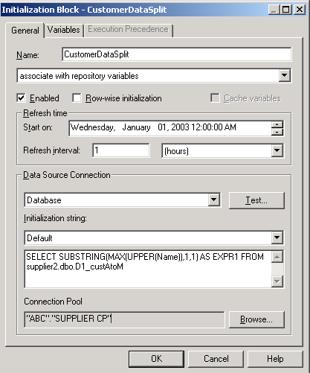
  - Click the Variables tab.
  - Click the New button.
  - In the Name, type EndPartOne.
  - Enter ‘A’ in the Default initializer section:
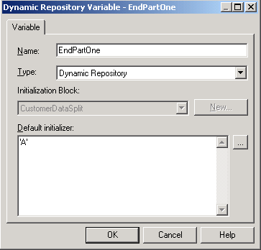
  - Click OK.
  - Select the General tab and click Test to test the variable:
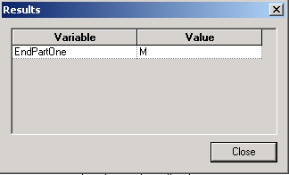
  - Click Close.
  - Click OK to save the initialization block just created.
  - Close the Variable Manager window.
- Use the variable to dynamically determine the content in the customer sources.
  - In the Business Model and Mapping layer, expand Customers and its Sources.
  - Double-click D1_customer2.
  - Select the General tab and verify that the source is inactive.
  - Click OK.
  - Double click D1_custAtoM.
  - Click the General tab.
  - In the Name, enter CustPartOne.
  - Verify that the Active box is checked.
  - Select the Content tab.
  - Change the expression to use the variable.
    - Open the Expression Builder by clicking the ellipsis button.
    - Highlight the < ‘N’ and press the BACKSPACE key to remove the text.
    - Click the <= button.
    - Select Repository Variables and double-click EndPartOne.
    - Click OK.
    - Check your result:
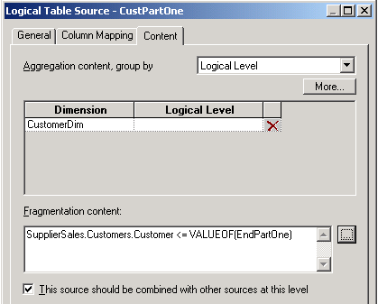
  - Verify that the This source should be combined with other sources at this level check box is checked.
  - Click OK.
  - Double-click D1_custNtoZ.
  - Click the General tab.
  - In the Name, enter CustPartTwo.
  - Verify that the Active box is checked.
  - Select the Content tab.
  - Change the expression to use the variable.
    - Open the Expression Builder by clicking the ellipsis button.
    - Highlight the >= ‘N’ and press the BACKSPACE key to remove the text.
    - Click the > button.
    - Select Repository Variables and double-click EndPartOne.
    - Click OK.
    - Check your result:
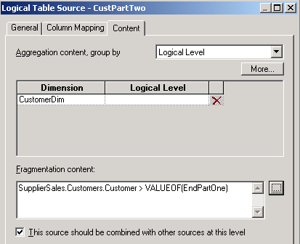
  - Verify that the This source should be combined with other sources at this level check box is checked.
  - Click OK.
- Select File > Check Global Consistency to validate your work.
- Select File > Save to save your work.
- Select File > Exit to close the Administration Tool.
- Test your results.
  - Start the Siebel Analytics Server service and restart the Siebel Analytics Web service.
  - Examine the initialization block in the log file.
    - Double-click C:\SiebelAnalytics\Log\NQQuery.log.
    - Scroll to the end of the file and scroll backwards to locate the initialization block:
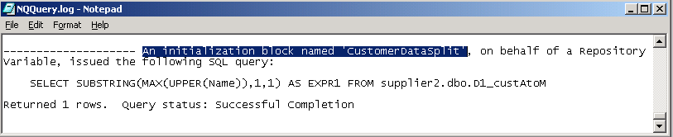
  - Select File > Exit to close the log file.
  - Start Siebel Analytics Web and log in as Administrator with no password.
  - Click the Answers link.
  - Click the SupplierSales subject area.
  - Select Customers.Customer.
  - Add a filter for customer names less than B:
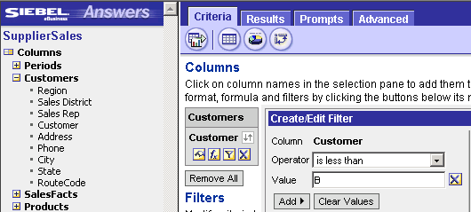
  - Run the query.
  - Verify that your results display names starting less than B:
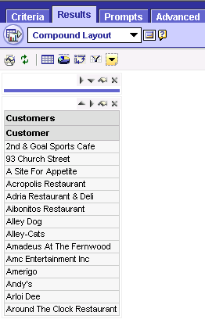
  - Verify that the query being issued is accessing the correct partition.
    - Double-click C:\SiebelAnalytics\Log\NQQuery.log.
    - Scroll to the end of the file and scroll backwards to locate the select statement.
    - Verify that the D1_custAtoM table is being used:
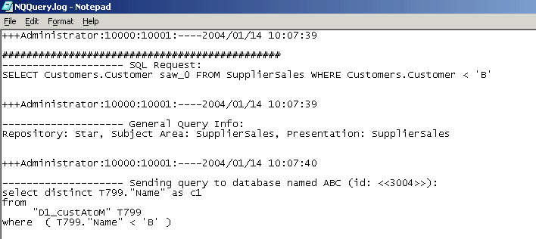
  - Select File > Exit to close the log file.
- Further test your results.
  - Return to Answers and change the filter to provide names greater than X.
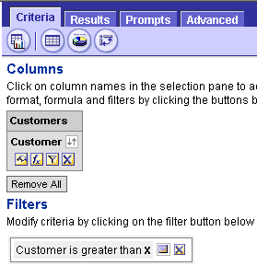
  - Run the query.
  - Verify the results:
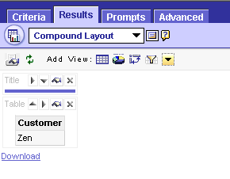
  - Verify that the SQL in the log file references the D1_custNtoZ table:
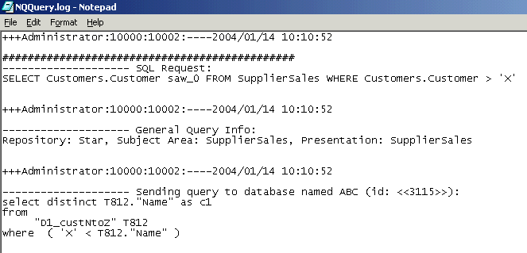
  - Select File > Exit to close the file.
  - Select File > Close to exit Siebel Answers.

